

**รายงานข้อเสนอโครงงานทางวิศวกรรม (ข้ามสาขาวิชา)**

**(Senior Project Proposal Report)**

**คณะวิศวกรรมศาสตร์ จุฬาลงกรณ์มหาวิทยาลัย**

**รหัสโครงงาน**  SP 3

**ชื่อโครงงาน**

(ภาษาไทย) อัลกอริทึมสำหรับการแก้ปัญหาการส่งเอกสาร

(ภาษาอังกฤษ) Algorithm for solving messenger service problem

**รายชื่อสมาชิกกลุ่ม :**

**ชื่อ – สกุล รหัสประจำตัว ลายมือชื่อ**

3.1. นาย ปรัชญา เอี่ยมทรงศักดิ์ 5730327221 …………………..

3.2. นาย ภคภูมิ ปธานราษฎร์ 5730430121 …………………..

3.3. นาย วสุวัชร สถิตธรรมจิตร 5731095821 …………………..

**รายชื่ออาจารย์ที่ปรึกษาโครงงาน**

‘ **ตำแหน่งทางวิชาการ/ชื่อ – สกุล ลายมือชื่อ**

4.1 ผศ.ดร.มาโนช โลหเตปานนท์ (..................................................)

4.2 ผศ.ดร.อรรถสิทธิ์ สุรฤกษ์ (..................................................)



1. **หลักการและเหตุผล (ที่มาและความสำคัญของปัญหา)**

Bangkok is full of businesses and companies. Due to the booming of startups, the demand of the messenger services are increasing. However, the existing messenger services have some downsides. To emphasize, the traditional messenger services generate all requests separately (1 job = 1 request). However, in the system we are trying to develop, the requests will be combined into a sequence in order to minimize total travel distances (1 sequence of job can be many requests from many users). Our group will not consider the bike depots because we assume that the depots are distributed all over Bangkok, we will separate requests into groups to generate jobs for deliverymen, and when all jobs are generated, the deliverymen can choose the nearest jobs to do. This is the advantage of our system because the bikes (deliverymen) can do many requests in one job with fewer distance than existing systems, assuming that the bikes have to return to their depots. For more understanding, please see the pictures below. 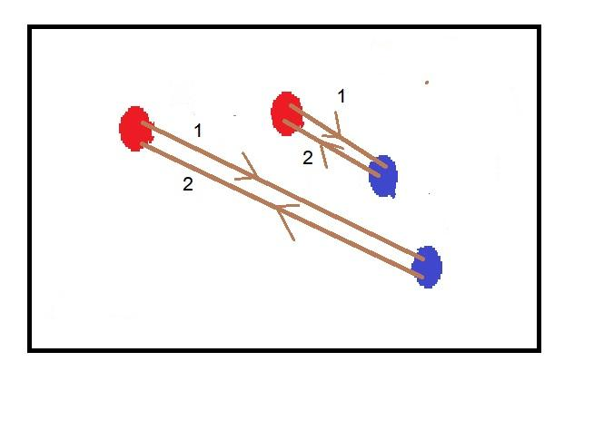

Fig. 1.1 – **The existing system. 2 job 2 requests**

Red nodes are pickup points; blue nodes are delivery points.

Assume that bikes have to travel to pickup points (red nodes), then delivery points (blue nodes), then their depots, which is somewhere near the pickup points (the lowest distances case is that the depots are at pickup points).

Fig. 1.2 – **The existing system. 1 job, 2 requests.**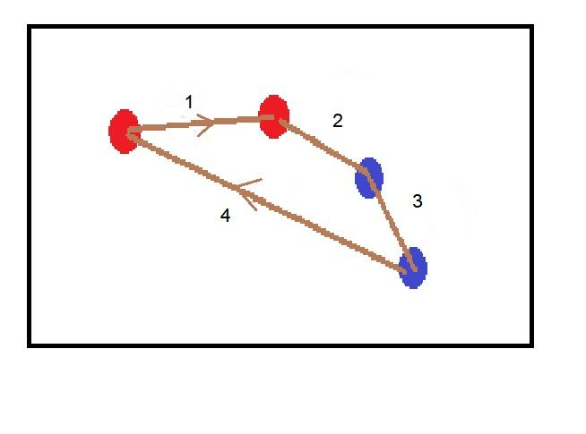

The requests are combined into 1 job, the total travel distances are decreased.

1. **วัตถุประสงค์ของโครงงาน**

The objective of this project is to find and analyze an algorithm for the messenger service problem. The messenger service is a service that users have requests to send documents. The service providers assign the deliverymen to pick the documents from users at the pickup points and deliver them to the delivery points. This problem can be classified as a pickup and delivery problem. Given, the requests from users (the pickup points, the delivery points, time windows, etc.) were known, we want to generate a sequence of jobs (the tours of vehicles) for the deliverymen with the lowest costs (travel distances) and still satisfy the constraints.

1. **ทฤษฎี/ งานวิจัยที่เกี่ยวข้อง**

The vehicle routing problem (VRP) is the problem which aim to minimize the cost of a set of routes for a fleet of vehicle which serves exactly once to a set of customers with known desire. The pickup and delivery problem with time windows (PDPTW) is a further concerned problem which include the optimal route for the pickup and delivery service with a time constraint i.e. time windowed. To solve this sophisticated problem, the special algorithm must be taken into account. Researchers have been doing this problem since early 1900’s but, there are still no exact answer for the problem. It is classified as a NP-hard problem; since the problem can be viewed as a Vehicle Routing Problem (VRP) with precedence constraints (e.g. node i have to be visited before node j), also the VRP’s general well-known case is the Traveling Salesman Problem (TSP. Therefore, many researchers have developed heuristics and meta-heuristics to solve this kind of problems rather than exact methods. There are many variations of the problem that are reviewed and listed below.

(note: all articles have the vehicle ‘load capacity’ in their constraints)

First, the single vehicle PDP. Xin-Lan Liao, et al. used the Genetic Algorithm (GA) to solve the Minimum Latency PDP (MLPDP)[1] . The objective was to minimize the sum of transportation time between demanders and the corresponding suppliers. The vehicle is capacitated and has LIFO constraints. The study focuses on many-to-many PDP, where a delivery customer can have any source of supply. They create their own techniques called reverse weighting to evaluate fitness, and Edge Aggregation Crossover (EAC). The results show that their EAC give better solutions than the other kinds of crossovers. GA is also used for Dynamic PDP problems (DPDP) (requests are dynamic, optimal solutions can change by those requests). Yamming and his team used GA hybrid with Local Sensitive Hashing (LSH) based local search called the multi-objective memetic algorithm based on request prediction to solve DPDP[2] (Yamming Yan, 2017). They also used Google Maps API and test the efficacy of their algorithm on the real map at Shenzen. Ant Colony Optimization (ACO) are also used. In the paper An Ant System for the Selective Pickup and Delivery Problem[3] (Yu-Wei Chang, 2016) (SPDP, not all pickup nodes have to be visited), the researchers found that ACO outperformed GA in terms of the solution quality (the route length).

Next, we will review more about the multi-vehicle PDP with one central depot. Margaretha Gansterer et al. used two variations of general variable neighborhood search (GVNS) namely sequantial GVNS (GVNSseq) and self-adaptive GVNS (GVNSsa) and compare them to the algorithm based on Guided Local Search (GLS) to solve multi-vehicle profitable PDP. The objective of the problem was to maximize the profit (revenue - travel cost). The results show that both variations of GVNS outperform GLS regarding to solutions quality but used more computational time[4] (Margaretha Gansterer, 2016). Another interesting article is “Nature-inspired Heuristics for the Multiple-Vehicle Selective Pickup and Delivery Problem under Maximum Profit and Incentive Fairness Criteria” (Javier Del Ser e. a.)[5]. The objective of the problem was to maximize profits while giving a fair share of net benefit among the company staffs based on their driving distance. They compare 4 meta-heuristics which are GA, Harmony Search, Firefly Algorithm, and ACO. The results showed that ACO solutions outperform all other algorithms in both test instances and practical test instances (Spain).

For the PDP with time windows (PDPTW) and handling operations (one depot), branch and price and cut technique was also used[6], but computational time was rather expensive (96 requests in up to 2 hours).

Next, for the Multi-Depot and Multi-Vehicle PDP (m-MDPDPTW), E. Ben Alaia and Imen Harbaoui Dridi et al. use GA to solve this problem[7] (E. Ben Alaia, Optimization of the Multi-Depot & Multi-Vehicle Pickup and Delivery Problem with Time Windows using Genetic Algorithm, 2013). They later extend the problem to multi-objective (minimize travel distance, tardiness time, and vehicles number) PDPTW[8] and solve it with GA hybrid with Pareto Dominance Optimization. Later, the bi-objective (minimize travel distance and tardiness time) dynamic PDPTW[9] solved with GA hybrid with aggregation method.

For the VRP problems, there are articles[10] [11], that show the superiority of ACO over GA in terms of solution qualities.

Swarm Optimization was also used to solve PDP and VRP, there is a literature review for this topic.[12]

A hybrid algorithm which primarily include the GA was also developed in order to encounter the problem.[13] In this paper, the author further develop a hybrid intelligent method for PDPTW. The hybrid intelligent algorithm transforms the multi-vehicle PDPTW problem into several single-vehicle PDPTW problems by using clustering algorithm, then using genetic algorithm to gain the best solutions of single-vehicle PDPTW problems, arrange them to construct initial solution for tabu search, and at last get the optimal solution by performing tabu search. In addition, a method to gain the minimal number of cluster is provided. So the algorithm guarantees the minimization of fleet. The objective function seeks to minimize total cost. Constraints ensure that each client is visited by exactly one vehicle, the equation of flow between clients and guarantee that the vehicles depart the depot at their starting time and return to the depot at the end of the planning period.

Ant colony algorithm alone is not the best choice for solving this complex problem. Elhassania MESSAOUD,Ahmed ELHILALI ALAOUI [14] use a hybridized ant colony to solve the VRP with dynamic customer with concerned traffic factor. In this work, the author focus on the dynamic version of the vehicle routing problem with the traffic factors. The main goal of this paper is to minimize the total cost, by using a hybridized ant colony system algorithm, which takes consider the reception of the new customers, and the alteration of the travel cost between two locations. In order to simulate a form of dynamicity, the notion of a working day is simulated by *T* seconds. Not all nodes are available at the start of the resolution. At the beginning of the day a tentative tour is created with the available nodes. The working day is divided into many time slices. At each time slice the solution is updated. This strategy allows the author to split up the dynamic problem into many static problems, which can be solved. A different approach consists to restart the algorithm when a node becomes available. This method could have a bad effect on the resolution algorithm, because this later can be stopped before a good solution is found.

There are many algorithm that can be useful in a VRPSDP (Vehicle Routing Problem with Simultaneous Delivery and Pick-up) optimization. One of the well-known is TS (Tabu search) algorithm. [Jinhui Ge](http://ezproxy.car.chula.ac.th:2308/search/searchresult.jsp?searchWithin=%22Authors%22:.QT.Jinhui%20Ge.QT.&newsearch=true) [15] use the improved TS algorithm in solving with several groups of instances. This paper solves the problem with simultaneous delivery and pick-up using the improved TS algorithm on the basis of the traditional TS algorithm. First, constructs the initial solution with the closest inserting algorithm. Second, to improve the initial solution, it uses2-opt to structure neighborhood Reference-set, which is divided into superior RefSetl and inferior RefSet2. Then, two solutions are selected respectively from RefSetl and RefSet2 to constitute a new solution, and form into Disperse and diverse Candidate-set. Finally, The Dynamic Tabu List is set up to make its length and construction change with search process and finally attains the purpose of improving the whole optimization. To test improved TS to solve the property of VRPSDP, the author use several groups of instances from the literature: The first instance used for testing is small-scale instances of 20 customers generated at random. The second instance is large-scale improved instances from Solomon's Benchmark Problems data set. The third instance is the real-life problem given by Min with the instance descriptor MIN 2.

[Nuo Zhu](http://ezproxy.car.chula.ac.th:2308/search/searchresult.jsp?searchWithin=%22Authors%22:.QT.Nuo%20Zhu.QT.&newsearch=true), [Chunfu Shao](http://ezproxy.car.chula.ac.th:2308/search/searchresult.jsp?searchWithin=%22Authors%22:.QT.Chunfu%20Shao.QT.&newsearch=true) [16] improved the most common algorithm, GA, in order to lower the convergence speed and improve the validity and feasibility in performing. In this paper, the improved VRPSDP mathematical model is set up on the basis of considering the impact of the amount of vehicles and the total cost of transportation. The model, based on basic genetic algorithm and modified algorithm, is worked out on Matlab program. In order to ensure the effectiveness of the chromosomes in the iterative process, chromosome encoding method of genetic algorithm and genetic operators are devised which are more suitable for solving vehicle routing problem. Simulation experiments are done by using emendatory Solomon R101 illustrative example. The optimal vehicle routing sequences and the optimal objective function values are processed with the two algorithms, and then the results are compared with each other according to the convergence process of the optimal solution. From the experiment, the fluctuation of the basic GA based on the traditional roulette is relatively large, the convergence speed is slow, and the transformation begins to become relatively stable at the 233rd generation. In addition, the value of the optimal objective function obtained by the improved genetic algorithm is more ideal and fit for the need of low transport costs. Therefore, the improved genetic algorithm which has validity and feasibility performs better than the basic genetic algorithm

A. L. Jaimes et all [17] studied about relationship between objective which are Number Of Route (R), Travel Distance(D), Travel Time(T), Uncollected Profit(P), Length Of The Longest Route(d) and Duration of the route that ends the latest(t) to reduce cost by using Spearman’s Correlation Coefficient and €MOEA (Multi Objective Evolution Algorithm) for evaluating the difficulty of MOPDP as more objectives are added.

[18] HUANG Wulan have developed their own techniques called Improved Genetic Algorithm (IGALS) to solves Simultaneous Pickups and Deliveries (with time windows) which is more effective than genetic algorithm (GA) by improved the convergence speed by using elite reserved section crossover strategy and improved the local search strategy based on road delay time. they comparisons data between IGALS and Branch & Bound Algorithm by testing with 10, 20 and 30 customers the results show IGALS is better than B&B at computing time and the number of iteration and comparisons data between IGALS and GA testing with 29 customers the results show GA fall into the local optimal solution after iterative 19,400 times and the object value is 2350.48 and IGALS fall into the local optimal solution after iterative 13,500 times and the object value is 2332.12, thus convergence speed of IGALS is faster than GA. Though IGALS quickly jump out of the solution but it obtained a more optimal solution.

[19] Studied An Ant System for the Selective Pickup and Delivery Problem (SPDP)   
The objective is to find the shortest route by relaxes the requirement visiting of all pickup nodes but impose load constrain to prevent impractical situation. To solve SPDP they used max-min ant system (MMAS is Ant Colony Optimization: ACO). The MMAS holds 2 features 1) the length of route constructed by ant is not fixed which corresponding to the number of selected pickup nodes and all delivery nodes. 2) this route can satisfy the constrain of vehicle load. Finally they comparison the route length that create by MMAS and GA, the result show the route length of MMAS is shorter than route length from GA.

1. **ขอบเขตของโครงงาน**

The scope of this project includes studying research papers, researching and developing our own algorithm for the problem, simulating and running test cases. We will not intend to develop an actual mobile application in this project.

About the problem, we are trying to find the best ways to generatejobs for service providers (deliverymen); each job consists of request(s) from user(s) who want to send documents, given traveling distances between places, time windows that users appoint to receive the documents, coordinates of places. We want to generate the jobs with the lowest total travel distances. We are focusing on documents messenger services, so the problem will have no load capacity constraints for the vehicles. We also assume that the amount of bikes in Bangkok are high enough so that we do not have to think about constraints of the number of vehicles, and there will always be a bike (deliveryman) who accepts any jobs we created.

1. **รายละเอียดการดำเนินงานโครงงาน**

First, we have studied research papers about the subject. Next, we will try to get clearer requirements and constraints for our own project. After that, we will try to formulate our problems and come up with the algorithms to solve them. Finally, we will simulate the situations and test them on computers to get the conclusion.

Apart from the study papers we reviewed, we found that Google has the Google Maps API that can get time and distance on the roads between places. We think these tools might be useful later in the project (e.g. making practical test cases using real distances and real traveling times, drawing the solution paths on the real map, etc.).

We also tried to get a hands-on experience in solving these kinds of problems, so we tried to solve TSP, visualize them and plot all the nodes and solution path, as can be seen below.

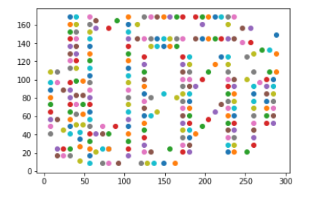

Fig.5.1 – TSP: All nodes to solve.

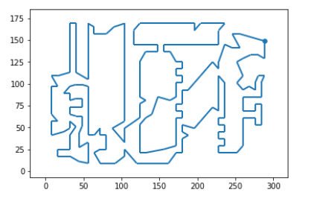

Fig 5.2 – TSP: The solution path (solving by Google’s ORTools).

About the test instances, we have Li and Lim’s and Cordeau’s PDP instances to test our effectiveness of algorithms. These instances were used for benchmarking in some research papers. However, the results cannot be directly compared with those from the papers, since the objective, constraints, and details are not the same.

1. **ประโยชน์ที่คาดว่าจะได้รับ**

**-** To develop the algorithms for solving the practical problem.

**-** To learn more about algorithms.

**-** To work as a team.

1. **เอกสารอ้างอิง**

[1] Liao, X.-L. C.-H.-K. (2014). A Genetic Algorithm for the Minimum Latency Pickup and Delivery Problem. IEEE Congress on Evolutionary Computation (CEC).

[2] Yamming Yan, Y. S. (2017). Multi-objective Memetic Algorithm based on request prediction for solve Dynamic Pickup and Delivery Problem.

[3] Yu-Wei Chang, C.-C. L.-K. (2016). An Ant System for the Selective Pickup and Delivery Problem.

[4] Margaretha Gansterer, M. K. (2016). The multi-vehicle profitable pickup and delivery problem.

[5] Javier Del Ser, A. I.-B. (2017). Nature-inspired Heuristics for the Multiple-Vehicle Selective Pickup and Delivery Problem under Maximum Profit and Incentive Fairness Criteria.

[6] Marjolein Veenstra, M. C. (2016). The pickup and delivery problem with time windows and handling operations.

[7] E. Ben Alaia, I. H. (2013). Optimization of the Multi-Depot & Multi-Vehicle Pickup and Delivery Problem with Time Windows using Genetic Algorithm.

[8] E. Ben Alaia, I. H. (2014). Genetic Algorithm with Pareto Front selection for Multi-Criteria Optimization of Multi-Depots and Multi-vehicle Pickup and Delivery Problems with Time Windows.

[9] Imen Harbaoui Dridi,E. Ben Alaia, P.Borne (2015). Heuristic Approach for the Optimization of The Dynamic Multi-Vehicle Pickup and Delivery Problem with Time Windows.

[10] Nature-inspired Heuristics for the Multiple-Vehicle Selective Pickup and Delivery Problem under Maximum Profit and Incentive Fairness Criteria. (n.d.).

[11] R. J. Kuo and Ferani E. Zulvia (2017). Hybrid Genetic Ant Colony Optimization Algorithm for Capacitated Vehicle Routing Problem with Fuzzy Demand - A Case Study on Garbage Collection System.

[12] Jyoti Gupta, Chander Diwaker (2015). Vehicle Routing Problem using Swarm Optimization Techniques.

[13] Liao Li, W. Y. (2007). A Hybrid Intelligent Algorithm for Vehicle Pick-up and Delivery. *the 26th Chinese Control Conference*, (pp. 469-473). Zhangjiajie, Hunan, China.

[14] Elhassania MESSAOUD, A. E. (2017). *Hybrid Ant Colony System Algorithm for the Vehicle.* Morocco.

[15] Ge, J. (2015). The Improved TS Algorithm for Vehicle Routing Problem with. *7th International Conference on Intelligent Human-Machine Systems and Cybernetics*, (pp. 91-94). Hangzhou, China.

[16] Nuo Zhu, C. S. (2010). Vehicle Routing Problem with Simultaneous Delivery and Pick-up Based on the Improved. *Fourth International Conference on Genetic and Evolutionary Computing*, (pp. 312-316). Shenzhen, China.  
[17]HUANG Wulan, Z. T. (2016). An Improved Genetic Algorithm for Vehicle Routing Problem with Simultaneous Pockups and Deliveries and Time Windows. *Proceedings of the 35th Chinese Control Conference*, (pp. 9639-9643). China.

[18] Jaimes, A. L., & Najera, A. G. (2016). Discrete Many-objective Optimization Problems: The case of the Pickup and delivery problem. *IEEE Congress on Evolutionary Computation.*

[19] Yu-Wei Chang, C.-C. L.-K. (2016). An Ant System for the Selective Pickup and Delivery Problem. *2016 International Computer Symposium*, (pp. 94-97). Taiwan.